Business Master Data Workshop A-1 Minutes
5.6.2026 |  | 1pm-4pm EST
Team | Service Cloud /CRM Team
Facilitators | Jose Diaz
Note taker | Taylor
Attendees
Notes:
PDD Approval Hierarchy
Dawn – Prime
Tara – Sub
Shibu – (Step to Reviewer)
SD à Jo
WAM Team

Employee on BP -> classification,

Ex. Tarah has a Service account then created as an employee for a 5series

Street 3 –used for Physical outside of Post box
for Private mailbox information
Use physical address for UPS Store
Private address, then takes you to
Different from public UPS PO BOX
Street Name for PO BOX

PO Box in the street name then DQM Validates against that

Employees created backoffice in Redwood à HR Team handling that

ZC BPs not created in CRM, intercompany business partners (Jo)

Do not solicit à customization in BP Level (will need to plug in for future state)

CamZone 0002 and 0003 have to do with when the have relationships set up
- Don’t use CamZone when creating Org BP
- Defaults to 0001

Camzone likely a carry over from legacy system (CAM – Corporate Account Management)
Camzone not in a place yet to determine whether or not we have in future state
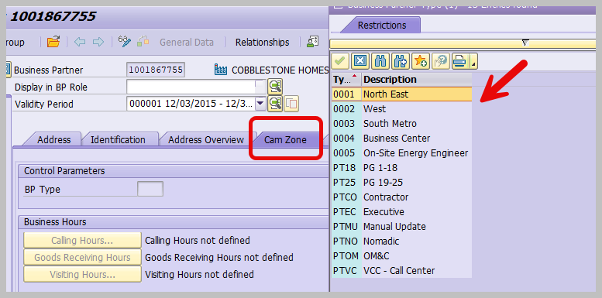

Inbound Call -> Directed to business center
CSR takes the call and does a move in, presents as a business center account as an alert

Bill Print Messages that go by BP classification

Bring The BP Classification

Account Maintenance Screen

VAPS was designed for customers going on the website, created the roles around the people accessing
(Customer supposed to enroll in ESP plan)
à it’s basically a do not solicit flag (this is specific to the VAPS marketing program)

ASP Sales Group
I'm not sure if we are going to look at a Persons BP but in the call center we do use the Do Not Solicit - Vaps, CSR's should be looking at this before they transfer a caller to HSA (ASP- Appliance Service Plan sales group)
à if they have the do not solicit, not supposed to transfer them
à this is on all calls not just move in, except for emergencies or threat of violence
à there is a do not solicit alert
à this alert still shows even if they’re on ASP

ASP then goes into SD Billing (could be on their utility bill or a separate bill)

Address Dependent Fields likely needed in future State

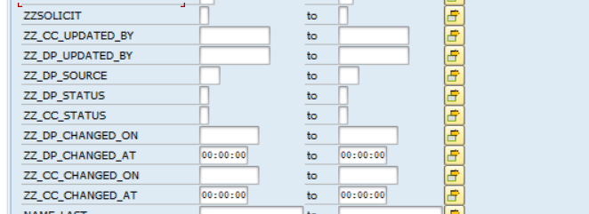

Do not solicit is not under an Org BP à only on a Residential BP

Payment Plans à Qualify based on income fields

Income Levels
Driving LMI (Low medium income flag) (no verification of)
Personalized Offering (prompts a few questions about income, then propose programs) à coming from ECC to WEB
Not an extended field in the BUT table its an extended field

Updated as a BP ID type (3 types, one for low, medium, high) (introduced 1-2 years back)

Flag determines shut off process (COVID, avoided shutting off low income people)
Different flag- not the BP ID, it’s an operand

Could help with Dunning Strategy (JJ doesn’t think Household income would necessarily help)
Doesn’t help with dunning procedures, may help with Dunning Strategy

The BC doesn't use that field at all, but the CCC does, last I knew.

The org BP does not have a do not solicit option today

Maintain Org in BP CRM
Spouse, Employee (report credit action on an account)

No Audit Credit Tranfer
Use it and keeping it
BP with multiple accounts under 1 business partner, if they stop service on1 address and end up with a credit balance, don’t want that credit balance transferring to another account, it will stay on the account and refund instead of transferring

BCC Dunning hold, shutoff notice suppression (ties to BP instead of Contract account)
Dunning Lock, at the contract account level

Check for Dunning Hold at Account Level or BP Level à Custom Field at BP Level
à it is at the BP level

Suppress dunning for special/ high value accounts (Michigan State University and GM)
4 days past due, 5th day prevents dunning order from going out so they can’t progress past dunning level 3

Stacey and Nikki Farmer and Nikki Murphy à direct questions to them on GCC

Don’t manually remove the flag, get strategic dunning notifications on a daily basis auto sent to us. Reach out to customer, then CE ensures they make payment, as soon as payment posts, it goes to the customer
à once its on there its on there

I just want to make sure the Business Center handles commercial and industrial customers and our processes are different from the residential customers.

CSRs shouldn’t be changing Business Center information

Non network role = least expansive, collection agency

BP Roles
Dawn and Shibu have a list of BP Identification Types (remove IBS ones), once we got in the 500s that was when the decision was made to remove
à BUT 0ID

If we remove this it would hurt the Equifax validation

EKUN table
à Data Masking was configured in EKUN but not BUT OID

Need to be masking military ID, Social, etc. (only show Last 4 digits)

Can show last 4 digits on the front end but need to mask all in the back end

Social Security and Drivers License can be maintained in two different places
BUTIDL: Show last 4 digits in the front end but in back end need to mask all digits for (passport, state id etc) Is it Masked in BDC?

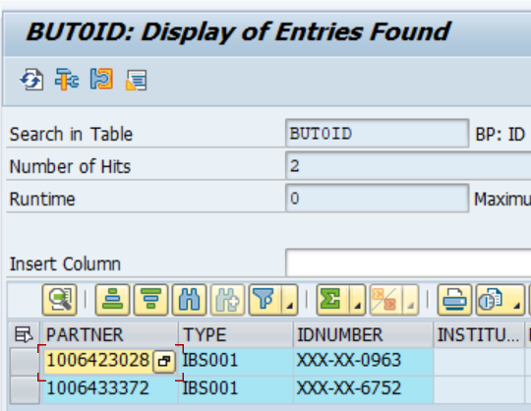

BP Relationships
Outage, contacts, parent child relationship, Gas trans, outage contact for corps (CAMS, SAMS, BAMS = ESM)
Nothing is changing for BP relationship

Case Management à Change Impact

Define Complaint Department

CE/Security Customer Teams

TBD for Security Roles since that is in Progress

Do complaints need to show in Service Cloud even if they’re closed

Mailing address and service addresses have different jurisdictions

No premises in system that do not have MI as jurisdiction

Emails TBD

Front office case: Only 1 case tupe that comes to CRM --> Emma X to billing team

Key Decisions/ Outcomes:
Call Center doesn’t use Titles à should we eliminate or keep, Verify based on Data, need decision to remove
Parking Lot
- 3 Overarching Roles for Service Cloud
Business Center Role, Contact Center, Management
(separate PDD based on these key Roles)

- Address Dependent Fields likely needed in future State

- BP ID Cleanup in Future Release

- Decision on Remove BP ID In Config system so SNP doesn’t carry it over

- Loading Cases into Service Cloud

- Notes history à System text generated in SAP (just a message not a contact), will have to revisit this process for a future workshop

- Potential Decision: Process Change to BDEX and EMA Case Routing

Action Items |  |  |  | Person Responsible | Deadline
Need to check if there are PO Boxes that are utilizing fields in CRM7, need to determine if we need this for future state. (DQM is not validating these fields)  à Private PO BOX Field is currently being used so will need that for future state |  |  |  | Shibbu and Dawn
Count tied to Camzone |  |  |  | Jose and Mohanta
Confirm whether or not Camzone is used by the ESM, what was the business reason behind it |  |  |  | Julie | Will become a decision
add to add another slide in deck for Changing a BP (Org and Residential) |  |  |  | Jose and Mohanta
Do we need to show VAPS Marketing Program for Agents in Service Cloud???? |  |  |  | Tara and Dawn | Will become a Decision
Complete title and suffix slide in WS Deck |  |  |  | Jose
If the data is stored in S4 do we have to go through approvals in order to show it in Service Cloud |  |  |  | Dawn and Shibbu
Count of population in the table for how many people have job title |  |  |  | Jose and Mohanta
Dawn to verify the differences in BP screens based on Role |  |  |  | Dawn
Inventory for Info Release Field |  |  |  | Dawn and Shibbu
Jose test in Dev if Drivers Lisence and Social Security Number in Dev environment  Payment in FPP1 / whatever T code he uses – make sure payment tab is hidden |  |  |  | Jose | Add as Issue if Payment tab is not hidden
- Not loading Cases into Service Cloud(in-flight complaint is a problem)  - Open complaints – notification to case  - Look if there are open or in progress notifications  - Need to understand what notifications are going to be changed to cases  - Strategize cut off period for loading |  |  |  | Jose and Mohanta | Will become a key decision

